DIONline

AFFILIATE
DIRECTOR

USER MANUAL

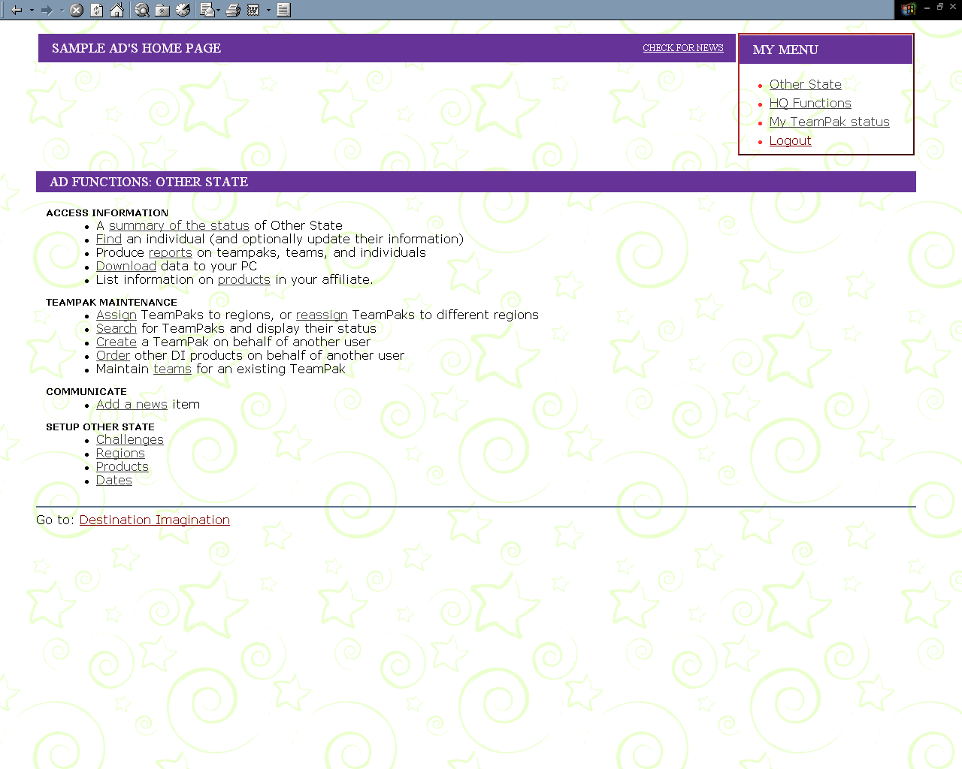

Fall 2002

Table of Contents:

Welcome to DION 3

THE LOGIN SCREEN – WWW.DIONLINE.ORG 4

AD MENU SELECTIONS 5

A MAP -YOUR AFFILIATE DIRECTOR DION MENU 6

AD MAIN MENU FUNCTIONS SECTION BY SECTION 7

TeamPaks need a Home! 7

Access Information 8

TeamPak Maintenance 16

Communicate 18

Setup “YOUR AFFILIATE” 18

FUTURE CHANGES 18

Welcome to DION

This year marks the debut of DI ONline, an integrated web-based system for administering DI challenges, TeamPaks, and teams.

DION was conceived after an extensive research project was undertaken to determine what ADs and RDs need to help make their job easier and more fun. DION is intended to make everyone's life easier: the staff in Glassboro, ADs, RDs, tournament directors, and participants. Of course, DION is new, and it's different, so initially it might seem a bit difficult or frustrating. So before we start looking at the details of administering an affiliate with DION, let's spend a short time looking at some of the philosophy behind the system. Understanding this should make a lot of what follows fall into place.

First, DION is intended to move information access out to affiliates and regions. ADs and RDs now have direct, real-time access to information relating to their affiliate. 'Direct' means that you have it available online, twenty four hours a day, seven days a week. There's no longer a need to wait for a weekly download, or to ask for special favors to get the information you need. 'Real time' means the data reflects the world as it is *right now*. If someone in some far flung corner of your affiliate registers a new TeamPak, your information is updated immediately. You always know the current state of your State!

You’ll know early in the year when there’s a challenge that everyone seems to pick– so you can adjust your appraiser training, for instance. You’ll know when a school you’ve been trying to recruit has suddenly downloaded the challenges and might now be interested in participating.

It’s not only ADs and RDs that can stay up-to-date – everyone with a DION ID has a customized DION home page – which shows them information that applies just to them. They’ll see their own TeamPaks and teams (and be able to update them), and they’ll see the news items that are meant just for them. They can see the exact status of any product orders they’ve placed with DI, as well as the status of their TeamPaks and teams.

Second, DION is designed to reduce workload. We try to eliminate entering data multiple times. Once a person has created a DION account and given the system their e-mail address, for example, you never need to enter their mailing information again – entering their e-mail address gives DION the information it needs to look their address up. Once a team has entered their team details, you can get those details from the system – instead of re-entering them at tournament time.

Key to all this is the idea that everyone involved with DI should register with DION. By having their own DION account, identified by their e-mail address, they can take full advantage of the system's ability to keep them up to date with their TeamPaks, Teams, Region, and Affiliate. As important, by encouraging your participants to use their DION account, you're cutting down on your own work. Once your members start using DION to find the status of the teams and TeamPaks, they'll be asking you far fewer administrative questions.

Lastly, DION is intended to be a growing system. From its roots as a registration system, it will branch out into areas such as volunteer management, tournament management, marketing, and so on. As ADs, you'll be providing the raw ideas that fuel much of this growth. We're relying on your feedback to help make DION better, each and every day. This is your system – please continue to help us build it to meet your needs!

THE LOGIN SCREEN – WWW.DIONLINE.ORG

This is the first DION screen. You can create a DION ID here, If you already have an ID, just enter it here, along with your password.

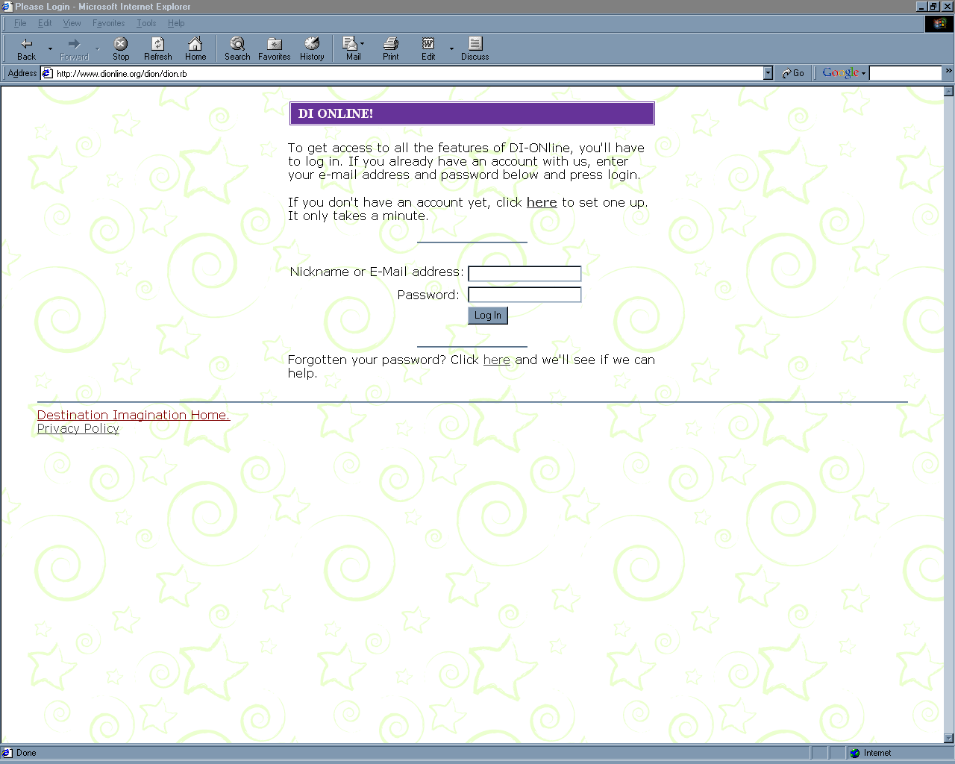
If you forget your password, don’t worry – you can get a new one sent to your email address – just click here…

This is the same log-in screen that all DION users see, but once you enter your DION ID, the system knows about you, and presents you with custom menus. Since as an AD, you’ve been granted special AD privileges in the DION system, you’ll probably have at least three basic menus.

1. Your Affiliate Director Screen,
2. Your General User Screen – the one that looks like all basic user screens, and
3. Your Personal TeamPaks Menu.

You can move between these screens by using the little “MyMenu” box in the upper right corner of your screen on all your Home Page screens:

Examples of all three follow on the next page…

YOUR AFFILIATE DIRECTOR MENU
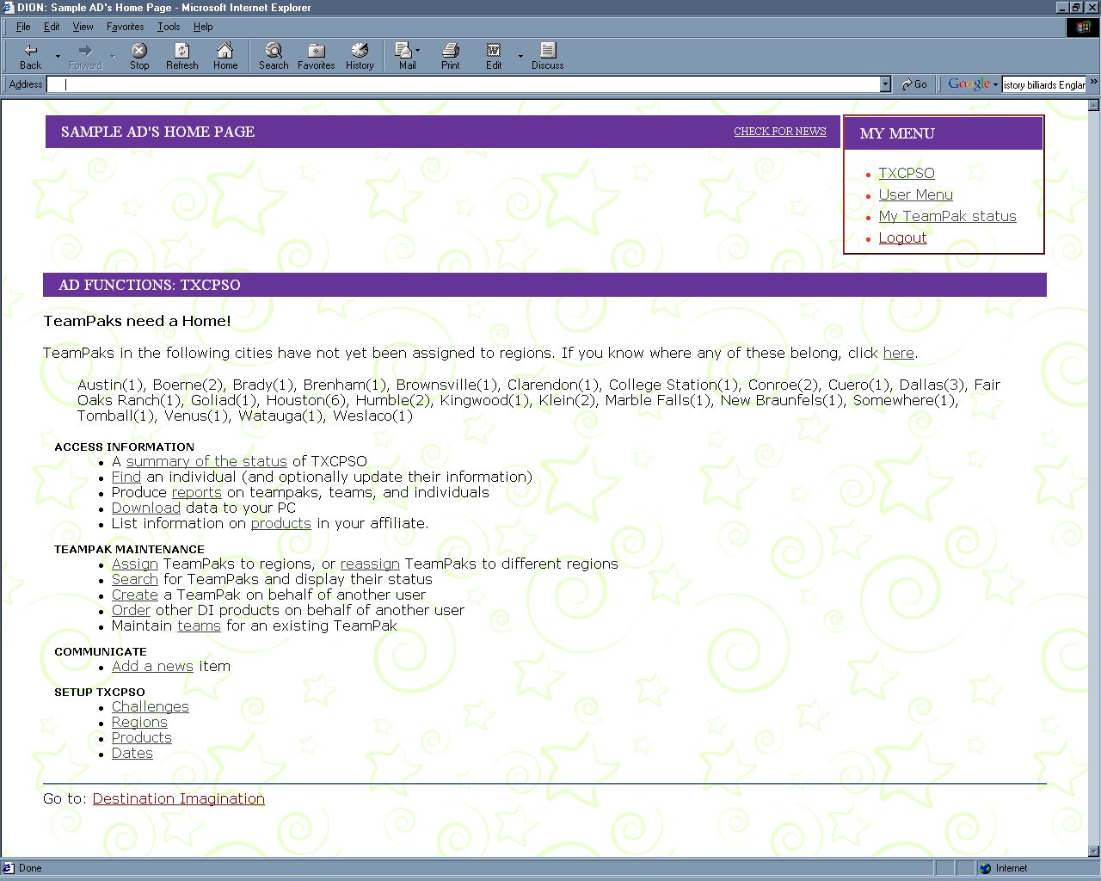
Click Here to get to this Affiliate Director Menu

YOUR GENERAL USER MENU:
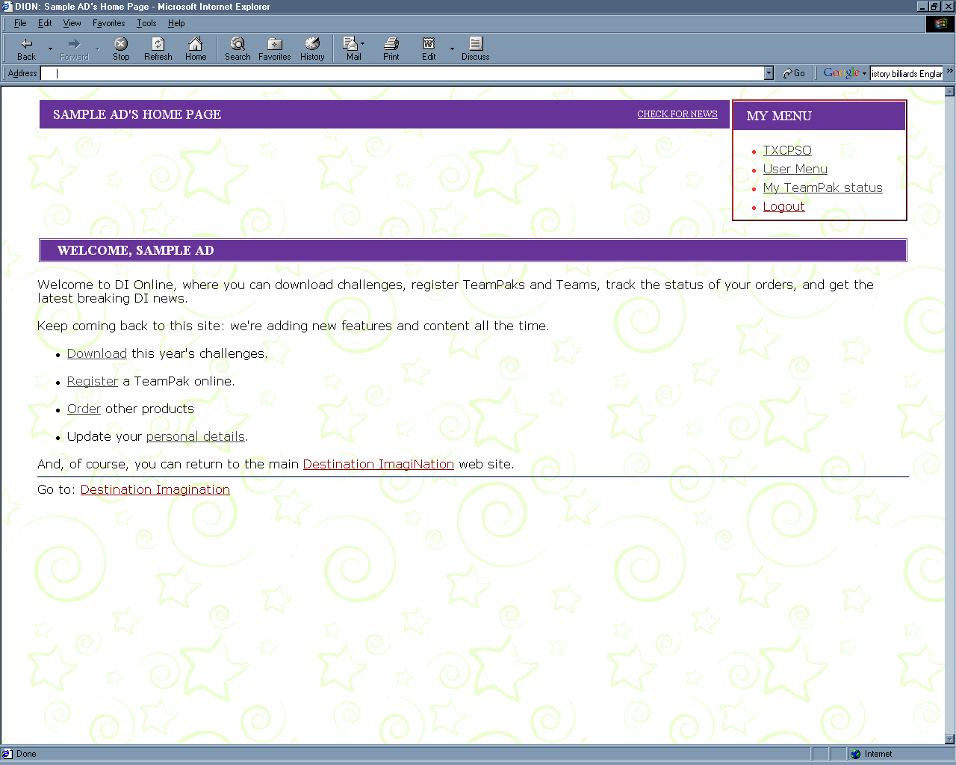
Click Here to get to this Personal User Menu

YOUR PERSONAL TEAMPAKS MENU:
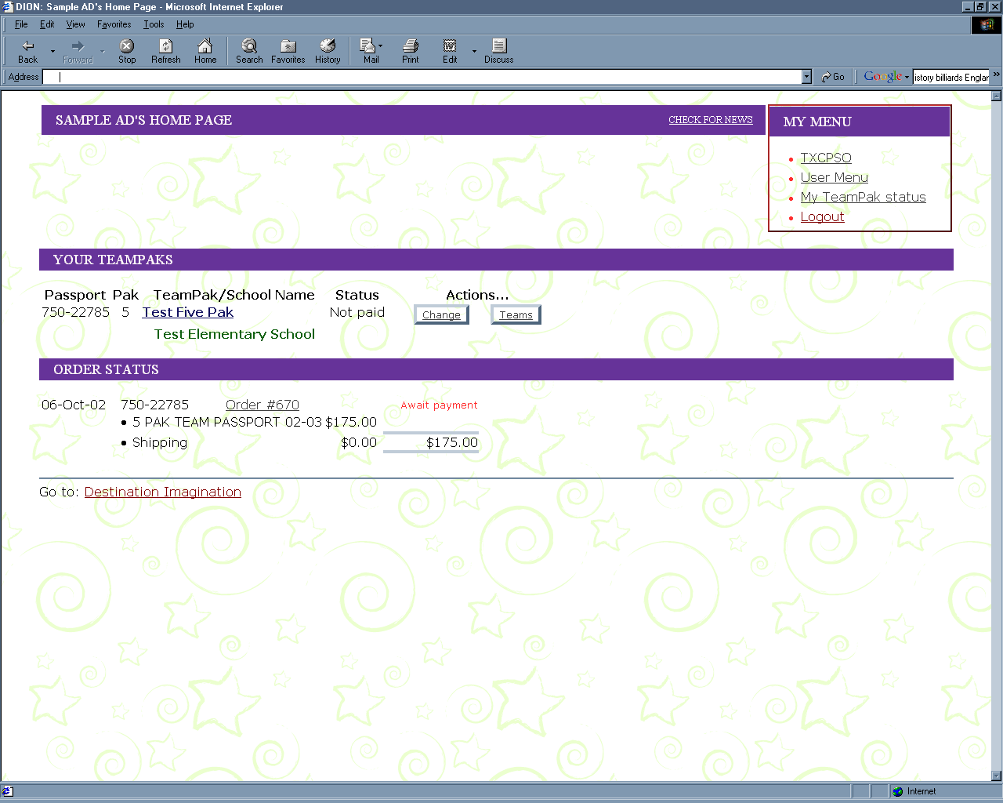
Click Here to get to the TeamPaks that are directly associated with your DION ID

Your AD Dion Menu

Click on your affiliate name to get to this AD Menu (Your menu will show your own affiliate name)
This affiliate has two TeamPaks that have not yet been assigned to a region. The list shows that both are in the same city (Old Saybrook). You can click here (or below in TeamPak Maintenance) to assign theseTeamPaks to regions

Go here for access to information – overall affiliate status, on-screen reports and spreadsheet downloads
Go here to work on TeamPaks – assign them to regions, create a Pak for someone else, or add teams to a Pak
Use these options to set up your affiliate at the start of the season
Add an affiliate news item
View or download this document

AD MAIN MENU FUNCTIONS
SECTION BY SECTION

TeamPaks need a Home!
This section is for affiliates with regions. When users register TeamPaks, they don’t assign their own regions – too many people don’t know the region they belong in! So, RDs or ADs have to assign each TeamPak to a region. (Next year, the renewing paks will have their region already assigned.)

This section gives you a quick look at the TeamPaks that still need to be assigned to a region. Click on “here” on the AD main page, or on “Assign TeamPaks to Regions” and it will give you the page you see here:

You’ll have a list of TeamPaks – each with a drop down window containing a list of the regions in your affiliate. Just select the region for each of the TeamPaks you wish to assign, and hit the ASSIGN button at the bottom of the screen.

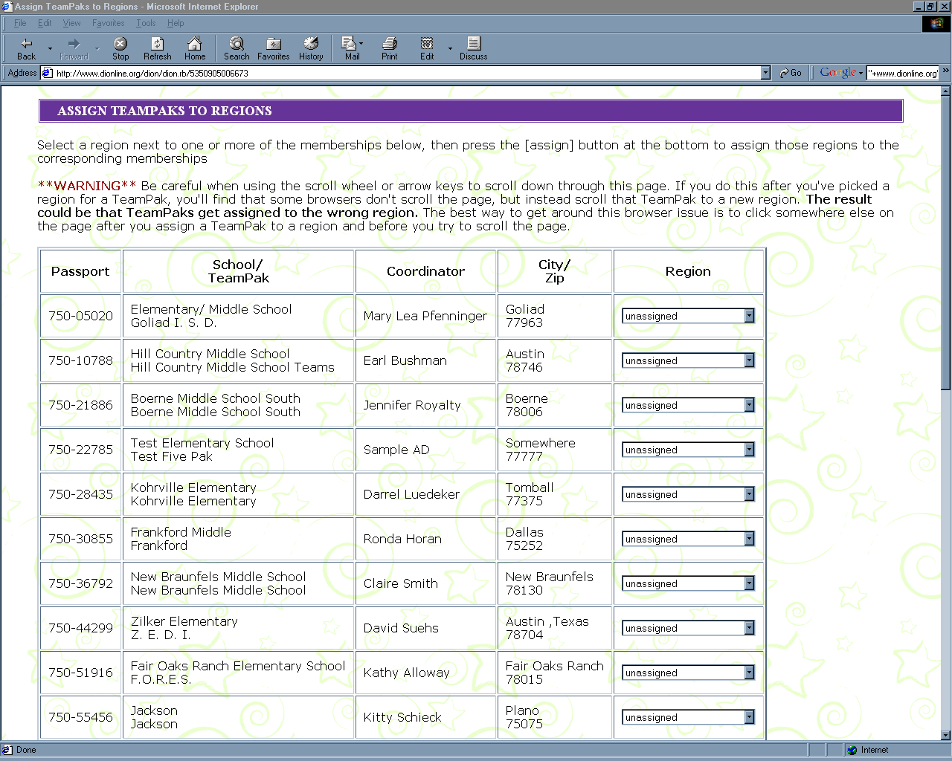

It’s important to note this small warning: once you select a region for a TeamPak, you must click again, somewhere outside of the region drop-down box – otherwise, when you scroll down the page, you’ll scroll through the regions in the box again, and not down the list of TeamPaks. We can’t change it – that’s the way internet browsers work.

Access Information
This section is where you can report and download info on just about anything related to your users or participants.

The first option A summary of the status of YOUR AFFILIATE gives you an overall picture of the affiliate – general information like:

Affiliate Registration Dates
Numbers of Users
A regions list (including the RDs)
Total numbers of one paks, five paks and their active (paid) status
Teams (along with the challenges and levels they’ve chosen).

An example is shown below:

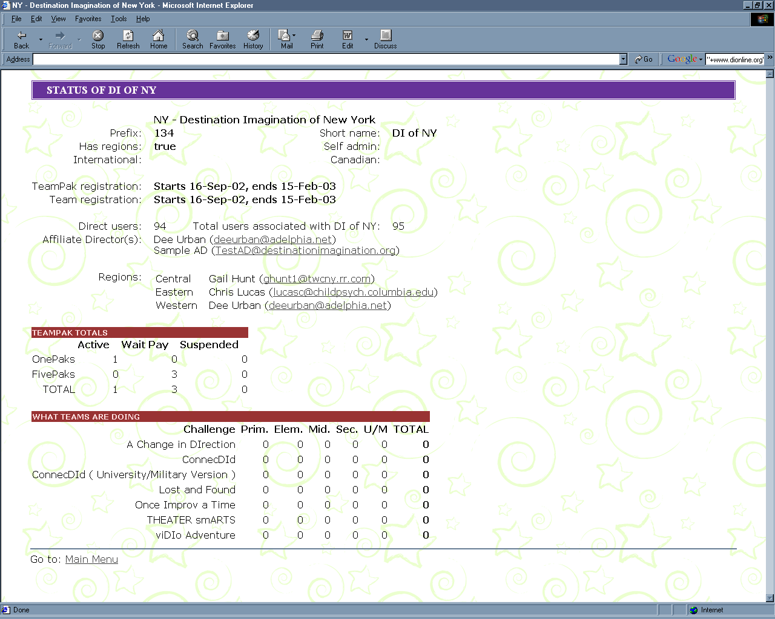

The next option Find an individual (and optionally update their information) does just what it says. It brings you to the screen shown below.

You can search for people by using any of 18 different criteria – including name, etc., but also including their roles, what challenges they’ve downloaded, etc. You can mix and match criteria – nothing is a required field, so if you want a list of ALL your users, just click “find user” without entering any limiting criteria.

Be careful asking for ALL users – in a large affiliate, that will generate a LARGE amount of data! It can take a few extra seconds to generate the report, and if you’re using a slower dial-up internet connection, it can take a few more seconds to receive the report.

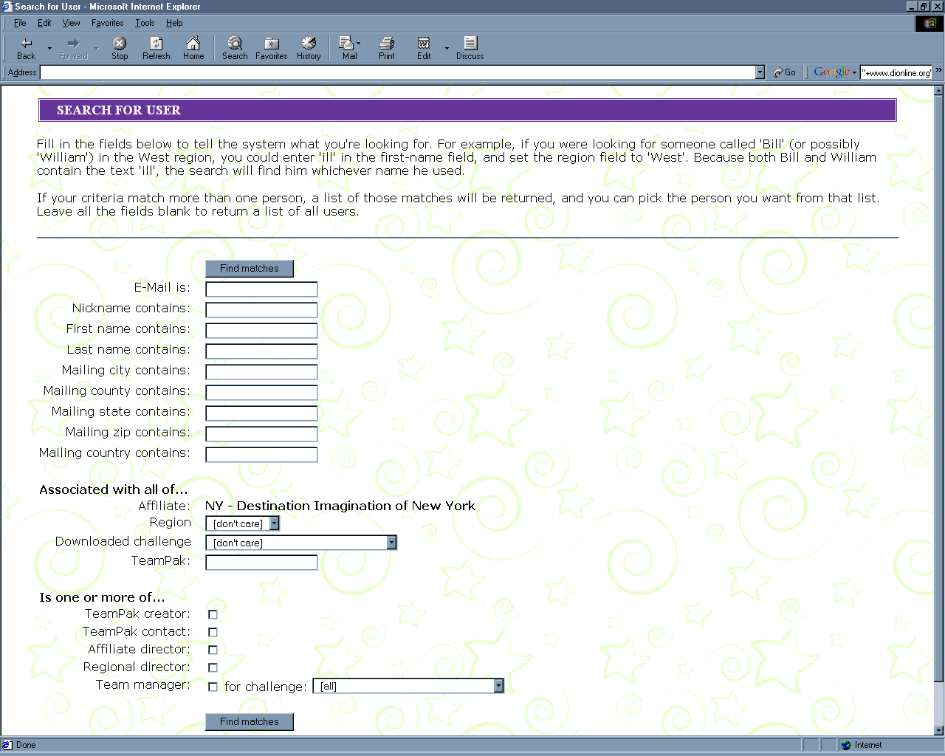

If you enter criteria that fits more than one person, you’ll get a list of all the users that match the criteria you entered. For more details about anyone on the list, you can just click on that record, and the system will show you a complete user record for them.

This is what a User’s record looks like.

You can see their contact details, all the roles that the system knows they hold – these can include things like RD, AD, ICM, TeamPak Contact, Team Manager, etc.

The record also shows everything a user has done each time they’ve logged into the system, including downloading challenges and creating TeamPaks. If they are a very active user, then you may only see the most recent of their history. In that case, there will be a place to click on the “RECENT ACTIVITY” line to show the entire history.

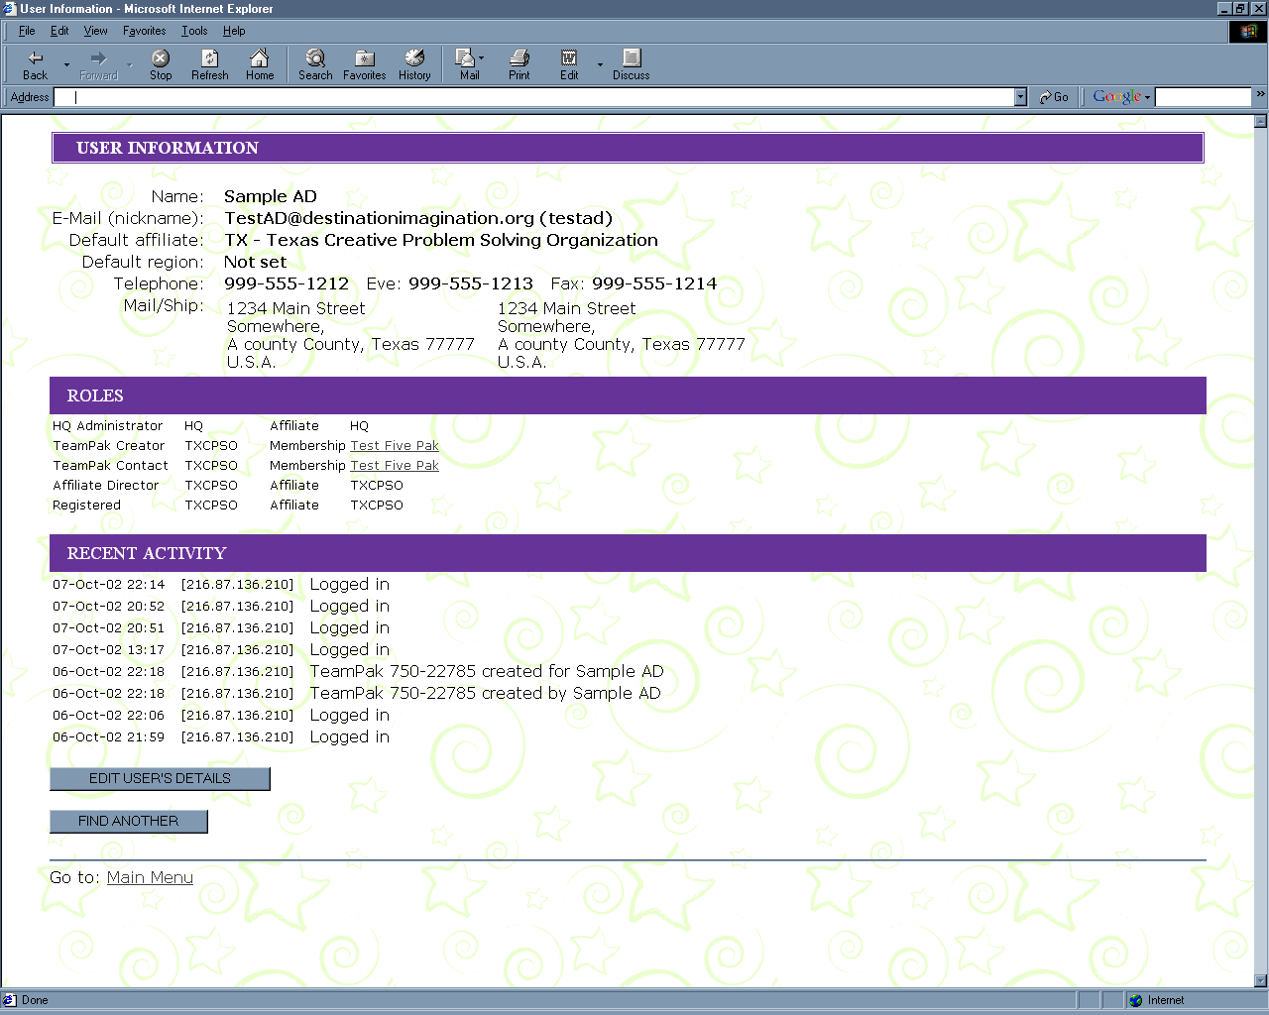

You can also update someone’s contact details here. If you know something has been entered incorrectly, or a User’s details have changed, just use that feature to edit the details. It won’t update any existing TeamPaks, but all new ones entered by that user will use the new details.

Produce reports on TeamPaks, teams, and individuals also does just what it says. You can search for TeamPaks, teams and individuals and people. There are lots of pre-formatted reports for each of the three, and there are an almost unlimited number of custom reports you can do, as well. All of these appear as on-screen reports (you can print them out if you wish.)

Download data to your PC does almost the same things as Produce reports, except instead of an on-screen report about TeamPaks, teams or people, you get the information sent to your PC in a format most spreadsheets will open automatically, so you can use it any way you like: to feed scheduling, to do a mail merge letter - whatever you need.

(Go to either Reports or Downloads. Remember, Reports creates an on-screen report, while Downloads creates a file in a format most spreadsheets will open automatically.)

The system will first ask you what you want to report on – choose:

Step 1. Report type | TeamPaks  Teams  Individuals

(For this example, let’s report on TeamPaks.)

The next step asks you which TeamPaks you want to know about:

Step 2. Search Criteria | All TeamPaks  Active TeamPaks  Unpaid TeamPaks  TeamPaks with no teams  Custom search

You can select all your affiliates’ TeamPaks, just the active ones (they’ve used a credit card, check or PO to cover their membership fee), just the unpaid ones, the ones with no teams. You can even select a custom set of TeamPaks.

If you choose to do a custom search, you can then specify the criteria the system will use to select the TeamPaks in your report.
Custom TeamPak Reports let you mix and match criteria like:

Passport is: 750- _________
Affiliate is: YOUR AFFILIATE
Region is: ________________ (pick from a list)
Passport name contains: __________________
E-mail address contains: __________________
School name contains: ____________________
School district contains: ___________________
Contact first name contains: ________________
Contact last name contains: _________________
Current status :_________________ (Paid, unpaid, etc.)
Payment ______________________
Check/PO number is: ____________________
Created in last: ________ days

So, if you want, say, all the TeamPaks in a certain district, just type that district into the School District Contains field. If you want all the TeamPaks that belong to a coordinator named Joe Wolfstein, just type Wolfstein into the last name field. You can use one or more (or none) of the criteria fields to precisely define the list you’re looking for.

If you want a list of all of your TeamPaks, don’t enter anything into the criteria boxes. Just click the “Select TeamPaks” button. Just remember - be careful asking for ALL TeamPaks – in a large affiliate, that will generate a LARGE amount of data! It can take a few extra seconds to generate the report, and if you’re using a slower dial-up internet connection, it can take a few more seconds to receive the report.

When you’ve finished entering your search criteria – just hit the “SELECT TeamPaks” button.

The last thing you’ll need to tell the system is the information you want to see about the TeamPaks you’ve selected:
Step 3. Data to Report
  Passport, name, type, status
  School name, district name, region
  Name, mailing address, phone, email of contact
  Name, mailing address, phone, email of creator

Again, you can mix and match your “Data to Report” selection, here in Step 3. You can pick just the first, just the last box, or any combination of the boxes, depending on what information you need about each TeamPak in your list

Here’s a sample of our TeamPak search results – in this example we only selected the first box in Step 3. The next example on this page was created by selecting all four boxes. Selecting other combinations will give you other results.

In all cases, you can click on each record in the list to get more information about that TeamPak.

Only selecting Passport, name, type, status in Step 3 creates a report like this:

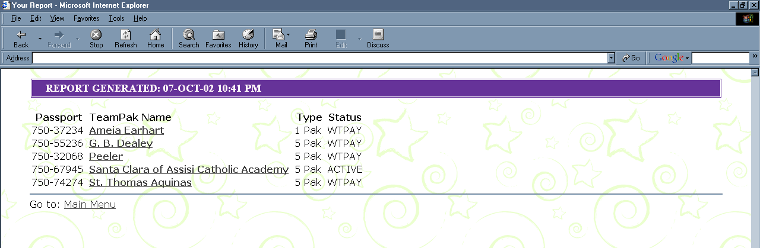

Selecting all possible information in Step 3 creates a report like this:

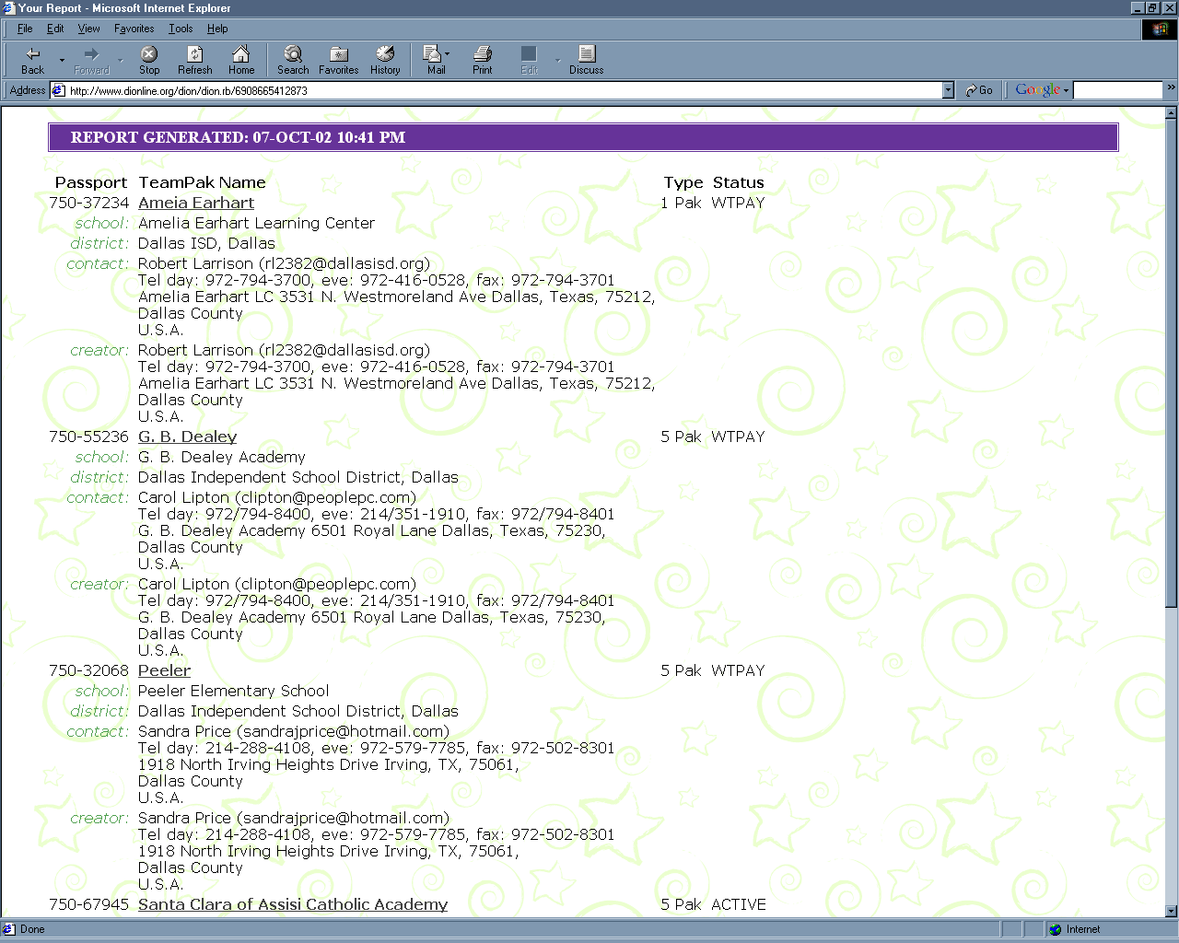

TEAM REPORTS
Had we selected TEAMS in Step 1, instead of TEAMPAKS, then we’d walk through a different set of options. TEAM searches get the following selections in Step 2:

Step 2. Search Criteria | All teams  Teams with no kids  Teams with kids  Teams competing at the wrong level  Custom search

Custom TEAM searches are defined using the following selection criteria:

TeamPak Passport is: 750- _____________
Affiliate is: YOUR AFFILIATE NAME is pre-filled, here
Region (Select from a list)
Team name contains: ___________________________
Challenge (Select from a list)
Team level (Select from a list)
TeamPak name contains: ________________________
School name contains: __________________________
School district contains: _________________________

So, we can get a list of all the teams doing a particular challenge, or all the teams at a certain level, etc.

Finally, Step 3, again, asks for the information needed in the report:

Step 3. Data to Report
  Team passport, Team name, TeamPak name, School name, challenge, level
  Team member name, D.O.B., Grade
  Full contact details for first team manager
  Name and e-mail for all team managers

A Team Report selecting just the top box of information in Step 3 would look like this:

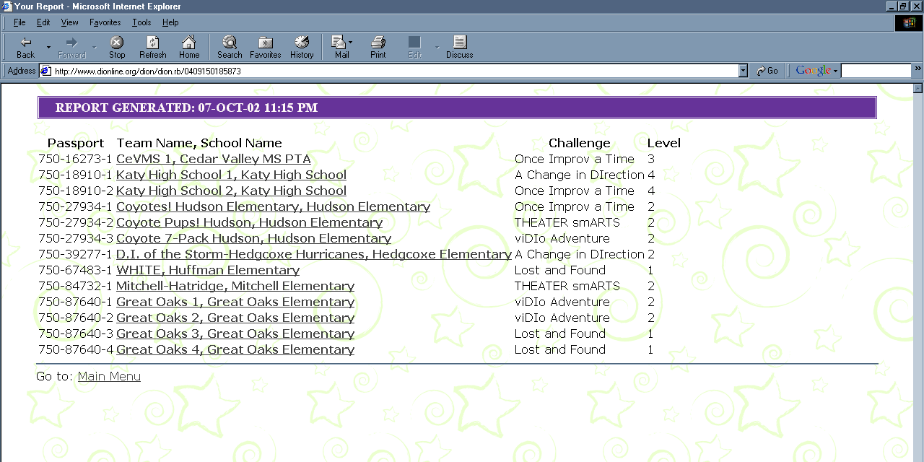

In either report, just click on the team name for more details about that team…

A team report which asked for all the information (clicked all the boxes in Step 3) would look like this:

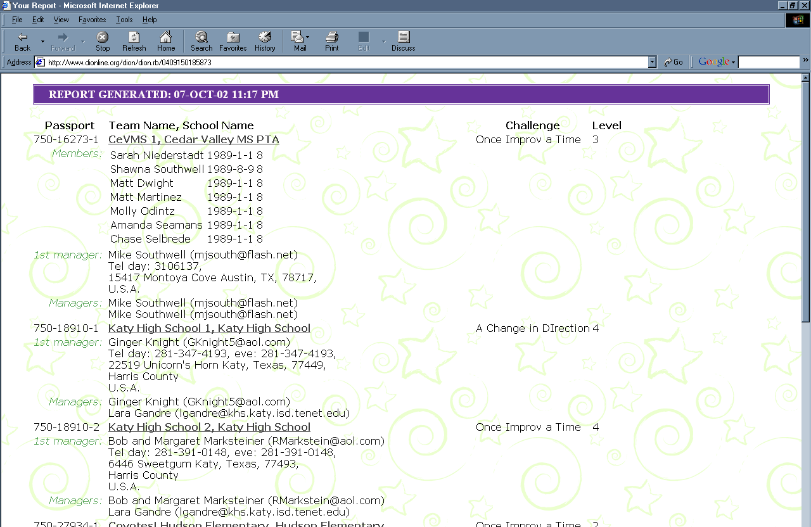
List information on products in your affiliate is fairly self-explanatory. Each affiliate can add a “mark-up” to certain products (for instance, you can add a mark-up to the Individual Passport or FivePak fees, so that the national organization collects the fees for you along with the national registration fee.) This menu choice shows you the products on which your affiliate has chosen to add an additional affiliate mark-up. (In this example, the affiliate only charges a fee on one-paks.)

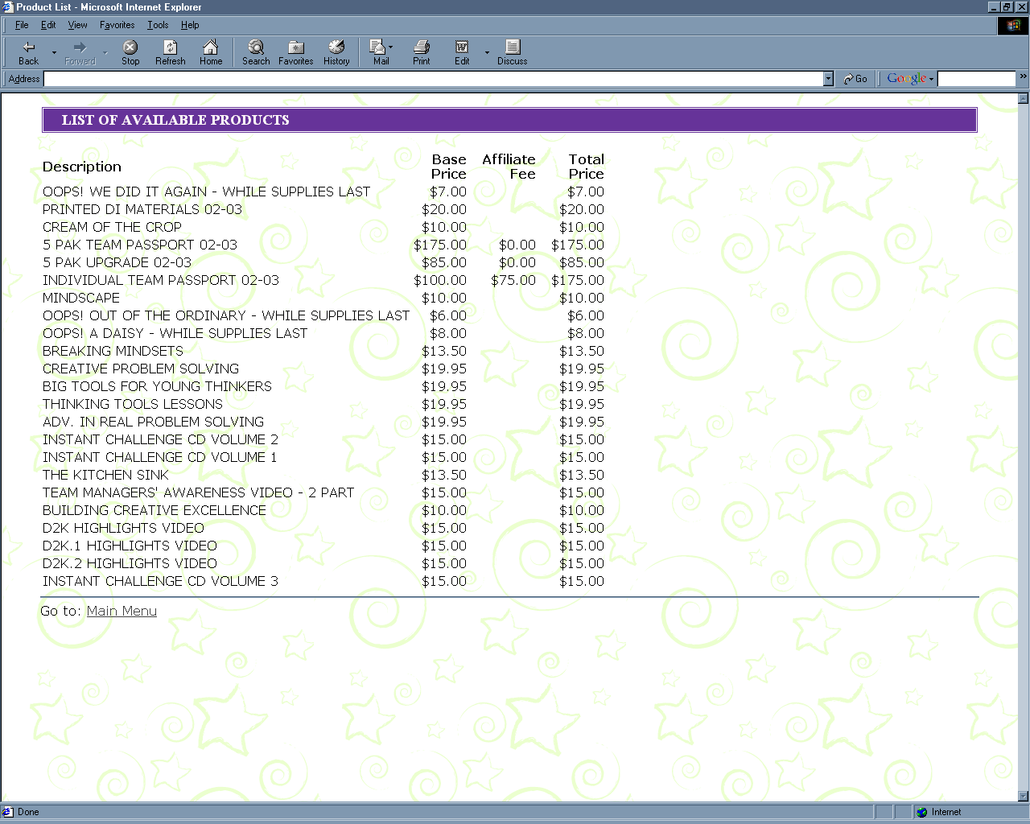

TeamPak Maintenance
Assign TeamPaks to regions, or reassign TeamPaks to different regions is just the same as TeamPaks need a home! up above. You can assign or re-assign TeamPaks – just select the ones you need and pick their region from the drop down box at the right of the TeamPak record.

Search for TeamPaks and display their status lets you search for TeamPaks by using any combination of 12 different criteria – including name, passport number, etc., but also including ones that have registered in the past “x” days, etc – so you can find your new ones easily.

The search here is kind of a short cut version of the reports function shown above. Basically, it selects “TeamPaks” in Step 1 and the basic set of information in Step 3 of the reports or downloads section. So you just specify is the search criteria – (Step 2).

Create a TeamPak on behalf of another user is lets you register an individual passport or a FivePak to help someone in your affiliate who might not have a DION ID or access to the internet. Order other DI products on behalf of another user lets you create a product order for someone else in much the same way.
Maintain teams for an existing TeamPak lets you maintain teams on TeamPaks registered in your affiliate. The TeamPak creators and contacts can do this, too, but sometimes ADs need to be able to help out their memberships that have trouble accessing the internet, etc.

When a TeamPak is created, it has no teams associated with it at first. Often, at the beginning part of the year, the teams aren’t yet fully formed – that usually happens later. When a team is set, then the TeamPak coordinator goes into the system and adds a team to that pak. Once they enter a Team Manager, then the TM can enter the rest of the details about that team, including the students’ details.

Sometimes, the AD may have to enter the team information – either the TeamPak coordinator cannot (or does not) enter the teams, and the AD needs to step in and help. This section, Maintain teams for an existing TeamPak lets you do just that.

Once you enter the passport number for the TeamPak, you’ll see the “Current Teams” screen for that TeamPak. If this is the first team in that pak, it will simply say “No teams have yet been registered for this TeamPak.” Just click on the “ADD TEAM” button. You’ll see the following screen:

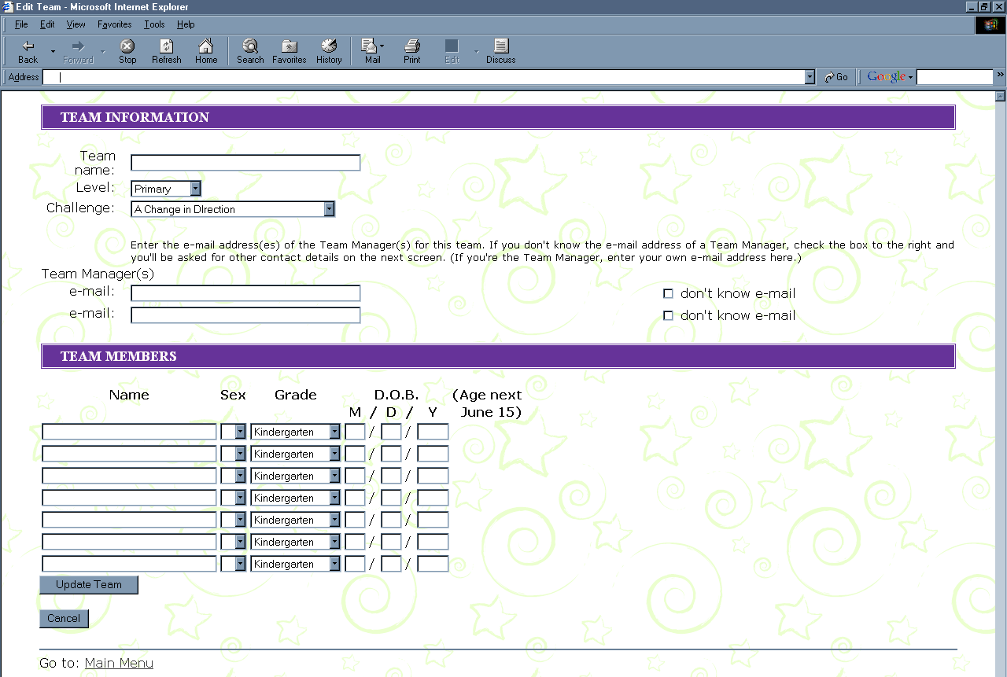

Simply enter as much information as you have. Once you enter a Team Manager email here: then that TM can access the TeamPak and update their own details. (If they don’t already have a DION ID, the system will ask you for their contact details, and will create an ID for them, so they can then access the TeamPak.)

Communicate
Add a news item is where you can post a news item – you can have it go to your entire affiliate, to just one region, or even to just a single user. The news item will be displayed at the top of the recipients’ DION Welcome Page. You can specify how long the news item will be displayed, as well as a title and the full story.

Setup “YOUR AFFILIATE”
This is where you do your general maintenance. You can set up your affiliate’s Challenges, Regions, Products, and Dates. This is where you set up what challenge/level combinations you’re offering, what regions your affiliate has and who their RD is, what products mark-ups you’re charging and when your registration cut-off is set.

Most likely, you’ve already done that once – in order to get your affiliate ready for the beginning of the year.

RD Set-Up
This section is also where you go to add and update your RDs. Each region can have as many RDs as you like – you enter them two at a time, but you can keep adding people who have RD access as many times as you like. There is also no limit to the number of regions to which a person can be assigned as the RD, even though that’s a rare occurrence. Sometimes, the same person is serving as RD for more than one region, and the system is happy with that. It will simply give them two separate menu selections in the “MY MENU” box at the top right of their main page – one for each region.

IMPORTANT - before you can add someone as an RD, they MUST ALREADY HAVE A DION ID. The way you add an RD to a region is by entering a person’s DION ID into the RD field for the region. Although DION IDs are email addresses, entering just any email address won’t work. If you try to enter an email address that isn’t a DION ID, the system won’t accept it – that’s because it takes all the contact information for the RD record from the DION ID record – that’s to save everyone re-keying contact information.

If you try to enter an RD and it doesn’t work because they don’t have an ID on the system, they’ll need to set up an ID (by going to the first page of the system – www.dionline.org and following the steps to set up their id). Once they’ve done that, you’ll be able to assign them RD permission level within a region.

FUTURE CHANGES
The DION system as it stands today is only the first phase of an exciting new development project. In the near future, the DION development team is planning many new features to keep improving the way we administer the program. Let us know what’s important to you - we hope to keep adding features that help make your job as AD easier and more fun. Stay tuned….

